**Performance Assessment: Procedures and Triggers**

All these questions use the **l_Lunches** database.

*Example: Write a query that displays all the employees*

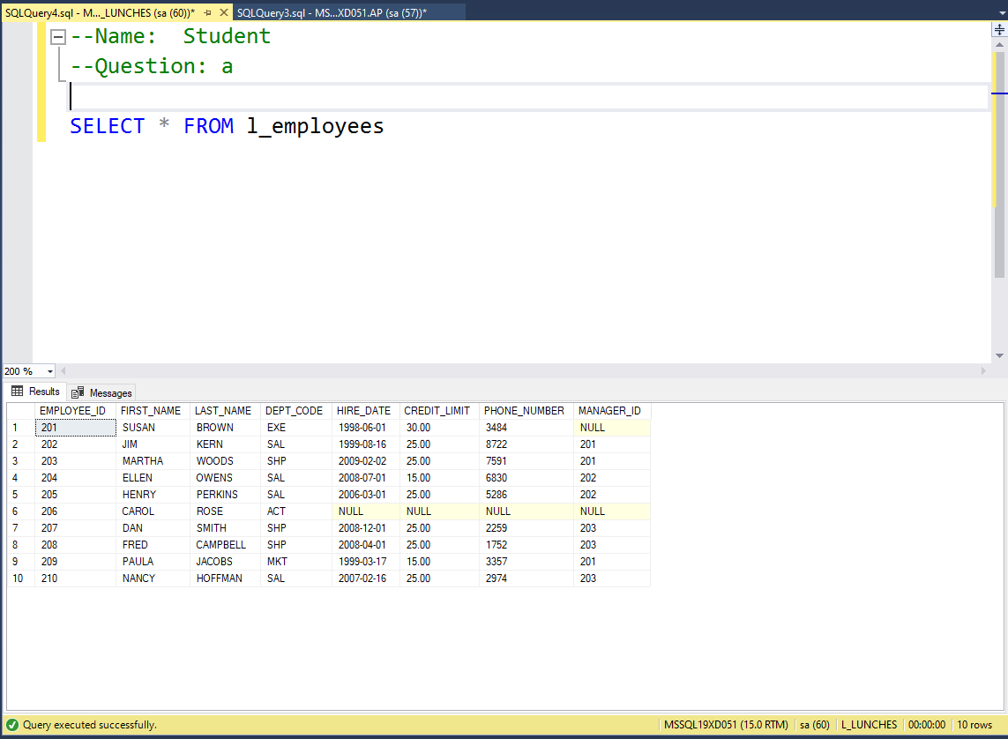

**Chapter 15. Procedures and Triggers**

*1)*  Write a script that creates and calls a stored procedure named spInsertFood that inserts a row into the l_foods table. This stored procedure should accept six parameters. One parameter for each of these columns: supplier_id, product_code, menu_item, description, price, price_increase.

Ensure that the price, price_increase (if sent) and menu_item are greater than 0.  Raise an error if they are not.

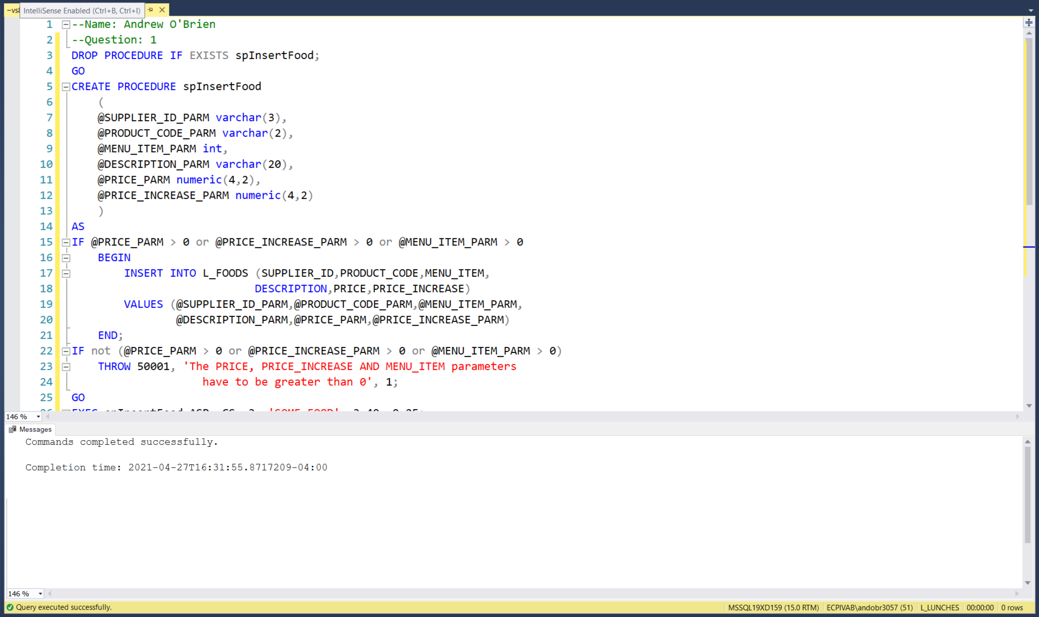

2) Code at least two EXEC statements that test the spInsertFood procedure created in step 1.

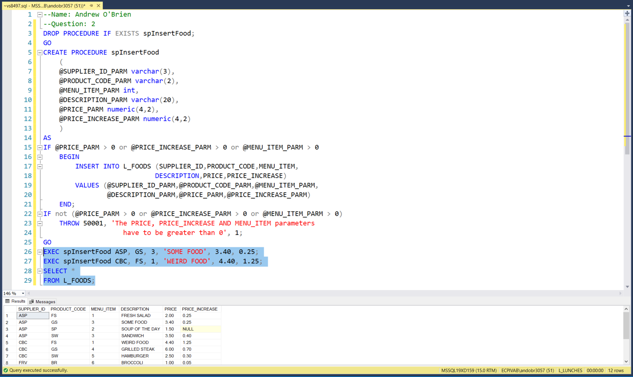

3) Create a Trigger on the l_foods table that uppercases the description for any insert or update statement.

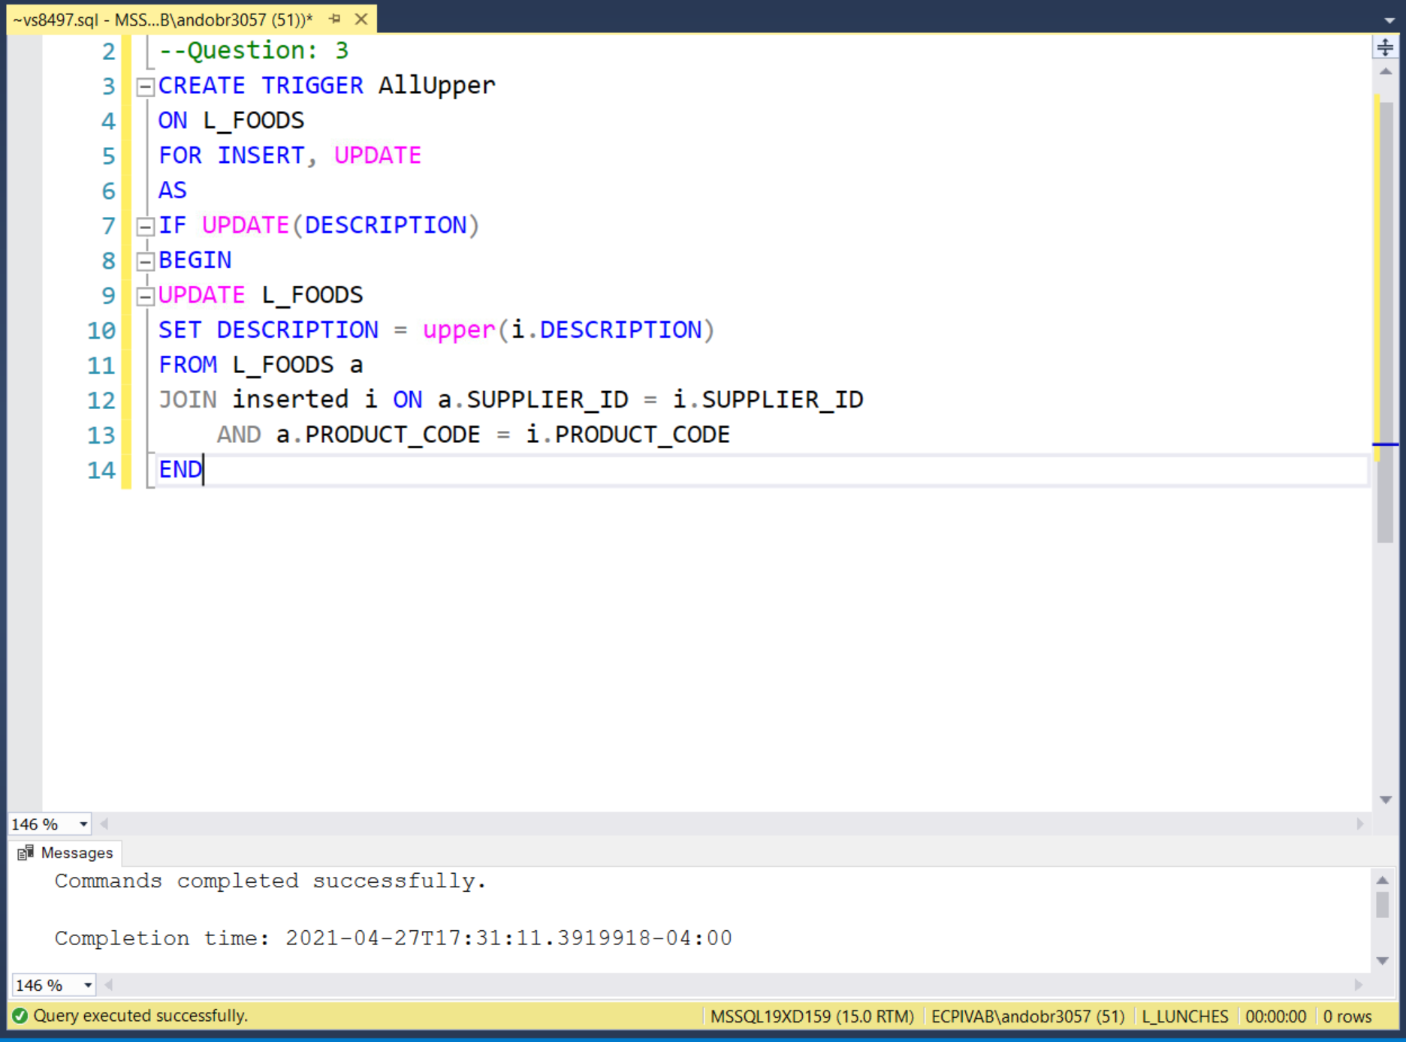

4) Test your trigger using a call to your stored procedure.

